Document 1
In this excerpt, the philosophy of John Locke is explained.
John Locke wrote that all individuals are equal in the sense that they are born with certain “inalienable” natural rights. That is, rights that are God-given and can never be taken away or even given away. Among these fundamental natural rights, Locke said, are “Life, Liberty, and Property.”
Locke also argued that individuals should be free to make choices about how to conduct their own lives as long as they do not interfere with the liberty of others.
The purpose of government, Locke wrote, is to secure and protect the God-given inalienable natural rights of the people. For their part, the people must obey the laws of their rulers. Thus, a sort of contract exists between the rulers and the ruled. But, Locke concluded, if a government persecutes (mistreats) its people with a ‘long train of abuses’ over an extended period of time, the people have the right to resist that government, alter or abolish it, and create a new political system.
Source: Constitutional Rights Foundation: Natural Rights. (Edited)

Document 2
This document discusses Anti-Jewish Legislation in Prewar Germany.
In the first six years of Adolf Hitler’s dictatorship, Jews felt the effects of more than 400 decrees (laws) and regulations on all aspects of their lives. The regulations gradually but systematically took away their rights and property, transforming them from citizens into outcasts. Many of the laws were national ones issued by the German administration, affecting all Jews. State, regional, and municipal (local) officials also issued many decrees in their own communities. As Nazi leaders prepared for war in Europe (in 1939), anti-Semitic legislation in Germany and Austria paved the way for more radical persecution of Jews.
Hundreds of individuals in all levels of government throughout Germany and Austria were involved in the persecution of Jews as they conceived, discussed, drafted, adopted, enforced, and supported anti-Jewish legislation. No corner of Germany and Austria was left untouched.
Source: U.S. Holocaust Memorial Museum (edited)

Document 3
After the attack on Pearl Harbor on December 7th, 1941, the United States president, Franklin D. Roosevelt signed Executive Order 9066. This law required that Japanese nationals, included Japanese-Americas, especially in California be taken to internment camps as they were seen as clear and present danger to national security.
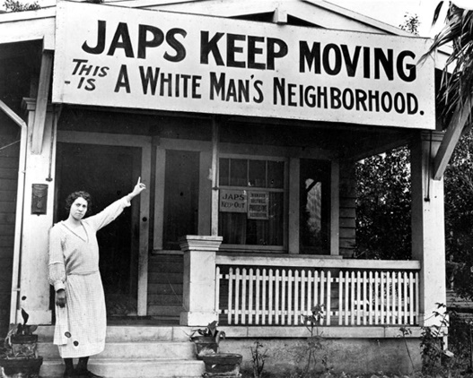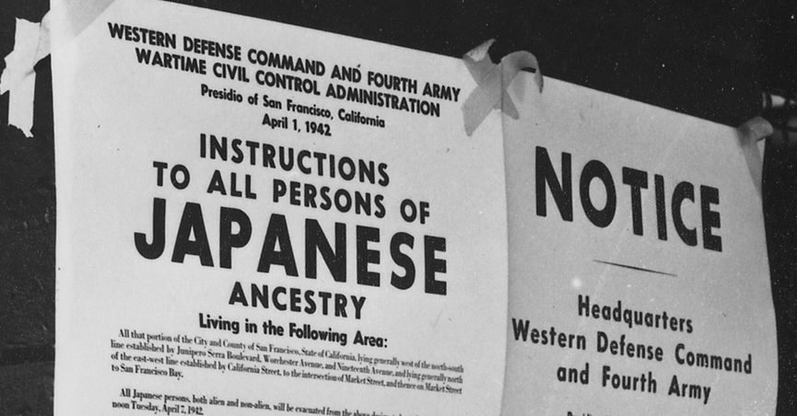

Document 4
From 1948 through the 1990’s, a single word dominated life in South Africa. Apartheid (Afrikaans language for “apartness” kept the country’s majority black population under the rule of a small white minority government. It would take decades of struggle to stop the policy, which affected every facet (aspect) of life in a country locked in centuries-old patterns of discrimination and racism.
The segregation began in 1948 after the National Party came to power. The nationalist political party instituted policies of white supremacy, which empowered white South Africans who descended from both Dutch and British settlers in South Africa while further disenfranchising (excluding) black Africans.
White settlers had historically viewed black South Africans as slaves, a natural resource to be used in changing South Africa from a rural society to an industrialized one. Slavery was abolished in South Africa in 1863 but at the same time gold and diamonds were discovered in the region. The white-owned mining companies now employed and exploited black workers.
These laws continued into the 20th century. Laws and apartheid policies prohibited black people from entering white urban areas without immediately finding a job. It was illegal for a black person not to carry a passbook. Black people could not marry white people. They could not set up businesses in white areas. Everywhere from hospitals to beaches was segregated. Education was restricted. In 1960, South African police killed 69 peaceful protestors in Sharpeville, sparking nationwide dissent (rebellion) and a wave of strikes.
More peaceful and violent protests sparked international attention. Nelson Mandela, the leader of the African National Congress, a political party for blacks had been imprisoned since 1964. Change was finally coming to South Africa due to other countries placing economic sanctions on the country. In February 1990, the new white Prime Minister F.W. de Klerk freed Mandela from jail and allowed him to run in a national election where for the first time, blacks could vote. In 1994, Mandela easily won the election and became the President of South Africa. Apartheid was finally over.
Source: Erin Blakemore, The harsh reality of life under Apartheid in South Africa. History Channel, 2019.
Document 5
In 1842, Hong Kong became a British colony and after 99 years, it was returned to China in 1997 under the principle of “one country, two systems.” This meant that while becoming part of Communist China, Hong Kong would keep a high degree of autonomy (self-rule) for the next 50 years. Hong Kong has its own legal system and borders. Its rights, including freedom of assembly and free speech were protected under these laws.
In June 2019 pro-democracy protests began in Hong Kong. People were opposed to a Communist China law that would have allowed extradition from Hong Kong to Mainland China. Hong Kong was a popular place with migrants and dissidents fleeing instability, poverty, or persecution in Mainland China. [Extradition is the surrender of an alleged criminal usually under the provisions of a treaty or statute by one authority (such as a state) to another having jurisdiction to try the charge]. The protests ended the law in September 2019 but the protests have continued and spread to reflect wider demands for democratic reform.
Rights groups have accused China of meddling in Hong Kong, citing examples such as legal rulings that have disqualified pro-democracy legislators. They have also been concerned by the disappearance of five Hong Kong booksellers, and a tycoon, all eventually re-emerged in custody in China. Artists and writers are under strict censorship. Communist China still controls Hong Kong’s election systems and the Legislative Council is not chosen by Hong Kong voters.
While most people in Hong Kong are ethnic Chinese, and although Hong Kong is part of China, a majority of people there do not identify themselves as Chinese. 71% of the people say they do not feel proud about being Chinese citizens. Protests have continued since 1997, but now the biggest ones tend to be of a political nature. Protests are one of the few ways that the people can make their opinions heard. Unfortunately the Communist Chinese government has responded to these protests in the recent months by using military force and violence.
Source: Helier Cheung and Roland Hughes: Why are there protests in Hong Kong? BBC News, September 2019. (Edited).

